**TASK 7: Operations on View**

1. Update

2. Alter

3. Delete

select * from sales_product_data

**1. Update query**

update sales_product_data set sumofsales = 100 where product_id = 'OFF-FA-10000304'

**Output:**

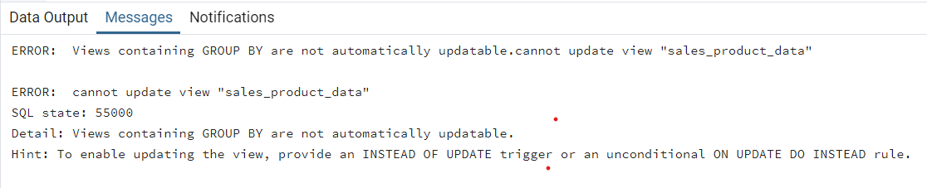

**2. Alter query**

**--Adding column:**

alter table sales_product_data add column sales2 int default 0 not null

**Output:**

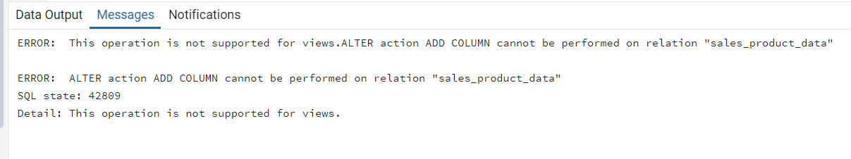

**--Dropping column:**

alter table sales_product_data drop column sumofsales

**Output:**

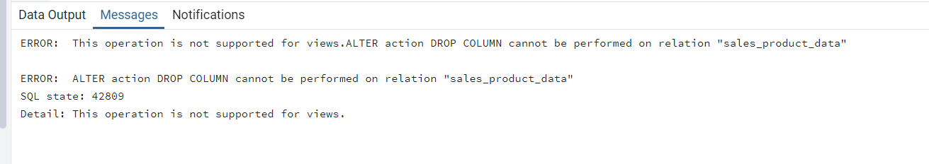

**3. Delete query**

delete from sales_product_data where product_id = 'OFF-FA-10000304'

**Output:**

